**ONLINE BANK MANAGEMENT SYSTEM**

### A Project Work

*Submitted in the partial fulfillment for the award of the degree of*

# BACHELOR OF ENGINEERING

### IN

### COMPUTER SCIENCE AND ENGINEERING

### Submitted by:

### KOMATIREDDY YASHWANTH REDDY

### UID:20BCS3996

### Under the Supervision of:

### MR.DIGVIJAY PURI

# DEPARTMENT OF COMPUTER SCIENCE AND ENGINEERING APEX INSTITUE OF TECHNOLOGY

### CHANDIGARH UNIVERSITY, GHARUAN, MOHALI - 140413,

**PUNJAB**

#### JULY,2021

**DECLARATION**

I, **KOMATIREDDY YASHWANTH REDDY,** student of **‘Bachelor of Engineering in Computer Science and Engineering**, Department of Computer Science and Engineering, Apex Institute of Technology, Chandigarh University, Punjab, hereby declare that the work presented in this Project Work entitled ‘**ONLINE BANK MANAGEMENT SYSTEM’** is the outcome of our bona fide work and is correct to the best of our knowledge and this work has been undertaken taking care of Engineering Ethics. It contains no material previously published or written by another person nor material which has been accepted for the award of any other degree or diploma of the university or other institute of higher learning, except where due acknowledgment has been made in the text.

**KOMATIREDDY YASHWANTH REDDY**

**UID: 20BCS3996**

**Date: 27-07-2021.**

**Place: Chandigarh University, Mohali,**

**Punjab**

# Table of Contents

|  |  |  |
| --- | --- | --- |
|  | Title Page  Declaration of the Student Abstract Acknowledgement  List of Figures  List of Tables (optional) Timeline / Gantt Chart | i |
| ii |
| iii |
| iv |
| v |
| vi |
| vii |
| **1.** | **INTRODUCTION\*** | **1** |
|  | * 1. Problem Definition   2. Project Overview/Specifications* (page-1 and 3)   3. Hardware Specification   4. Software Specification 1.3.1   1.3.2  … | 1  2  3  4  4 |
| 1. **LITERATURE SURVEY**    1. Existing System    2. Proposed System    3. Feasibility Study* (page-4) 2. **PROBLEM FORMULATION** | | **5** |
| 5  6  7 |
| 9  16  18  19  22 |
| 1. **OBJECTIVES** 2. **METHODOLOGY** 3. **CONCLUSIONS AND DISCUSSION** 4. **REFERENCES** | |

**Abstract**

The Online Bank Account Management System is an application for maintaining a person's account in a bank Online. In this project, I tried to show the working of an Online banking account system and cover the basic functionality of an Online Bank Account Management System. To develop a project for solving financial applications of a customer in a banking environment to nurture the needs of an end banking user by providing various ways to perform banking tasks. Also, to enable the user’s workspace to have additional functionalities which are not provided under a conventional banking project. The Online Bank Account Management System undertaken as a project is based on relevant technologies. The main aim of this project is to develop software for Online Bank Account Management System. This project has been developed to carry out the processes easily and quickly, which is not possible with the manuals systems, which are overcome by this software. This project is developed using C or C++ language. Creating and managing requirements is a challenge of IT, systems, and product development projects or indeed for any activity where you have to manage a contractual relationship. The content management system deals with data entry, validation confirm and updating whiles the interactive system deals with system interaction with the administration and users. Thus, the above features of this project will save transaction time and therefore increase the efficiency of the system.

**---------------------------------------------------------------------------------------------------**

iii

**Acknowledgment**

I would like to express my deepest sense of gratitude to my reverend teacher and supervisors Mr. Digvijay Puri, Coordinator & Lecturer, Department of Computer Science & Engineering (CSE), Chandigarh University, and, for his untiring guidance, constant supervision, enthusiastic encouragement, sagacious advice and effective surveillance throughout the entire period of my project & thesis work and preparation of the manuscript. I greatly say thank you. Wish to express my heart full thanks to all of my honorable teachers of the Department of Computer Science & Engineering (CSE), Chandigarh University. I sincerely thank our Head of Department Mr. Vikas Wasson for giving me the chance as well as the support for all the time being. I am thankful to Mr. Digvijay Puri, who is having a vast knowledge of programming languages like C, C++, etc., System Analysis and Design & Programming concepts which are the building block of the project.

I also want to express my appreciation to my classmates and friends who helped me in one way or another during the course of developing this project. They endured the long hours of my absence during the development of this project. I deeply express my respect to my parent and my teachers for their blessing and constant inspiration in every step of my education. I am very thankful to my all friends for their help and company during the project & thesis work and for encouraging me to carry out the work.

Finally, I express my gratitude to our professor and instructor Mr. Digvijay Puri for granting me the opportunity to write this intern project report.

**Date: 27-07-2021**

**KOMATIREDDY YASHWANTH REDDY (20BCS3995)**

**Chandigarh University, Mohali, Punjab**

iv

# INTRODUCTION

**1.1 Problem definition:**

The “Bank Account Management System” project is a model Internet Banking Site. This site

The “Online Bank Account Management System” project is a model Internet Banking Site. This site enables the customers to perform basic banking transactions by sitting at their office or homes through PC or laptop. The system provides the access to the customer to create an account, deposit/withdraw the cash from his account, also to view reports of all accounts present. The customers can access the bank's website for viewing their Account details and perform the transactions on account as per their requirements. With Internet Banking, the brick-and-mortar structure of traditional banking gets converted into a click and portal model, thereby giving a concept of virtual banking a real shape. Thus, today's banking is no longer confined to branches. E-banking facilitates banking transactions by customers round the clock globally.

**1.2.1 Project Overview/Specification:**

1. The “Bank Account Management System” project is a model Internet Banking Site. This site

Client can do his operations comfortably without any risk or loss of his

1. **Create New Account:** A customer who has an account in the world can create a virtual account through this module or they can create a new account in this module itself. And the account will be created successfully with a password of your choice online in this module.
2. **Login:** Virtual account holders can log in to the system using your account holder's name and password. Thus, this is the secured login page for the customers.
3. **Virtual Account:** After the approval of new virtual account creation, the customer is assigned a unique virtual account number to make the online money transactions. This module views the details of the logged customer's virtual account.
4. **Transaction:** This is the module to make fund transfer to the virtual bank account holders or the usual bank account holders from the customer's specified bank account.
5. **Close Account:** In this module, the customer or client can close their virtual

account through the total online process using the customer details.

1. **Mini Statement:** This module provides the customers whole information

Of transaction and the balance amount with the date accordingly.

**1.2.2 Specifications:**

**Customer Satisfaction:**

* A client can do his operations comfortably without any risk of loss of his privacy.
* Our software will perform and fulfill all the tasks that any customer would desire.

**Saving Customer Time:**

* A client doesn't need to go to the bank to do the small operation.

**Protecting The Customer**:

* It helps the customer to be satisfied and comfortable in his choices, this protection contains the customer’s account, money, and privacy.

**Transferring Money:**

* Help client transferring money to/or another bank or country.

**1.3 Hardware Requirements Specification:**

* **Processor:** Intel 386 or higher
* **Hard Disk:** 256 MB
* **Min RAM Size:** 512 MB free ram.
* **Min Hard Drive** Space: 25 MB.

**1.4 Software Requirements Specification :**

* **Programming language: C++**
* **Operating System: Windows.**
* **OS Required**: Microsoft DOS, Microsoft Windows 3.1, or later, PC DOS.
* **OS Family:** Windows OR MAC

1. **. LITERATURE REVIEW**

**2.1 Existing system:-**

* With the extensive technology innovation and telecommunications, we have seen new financial distribution channels increasing rapidly both in numbers and form, from ATMs, telephone banking to PC banking (Easing wood & Storey, 1996), and Internet Banking is the latest in the series of technological wonders of the recent past (Mols, 1999).
* Following the boom of the Internet, the Internet can no longer be considered a “fad” or the preserve of “techies” and “computer nerds”. Commercial uses of the Net have become the fastest-growing part of the World Wide Web (WWW) (Hamid et al, 2007). About the same time, Internet Banking was thought to signal a revolution in banking distribution. Banks invested heavily in the development of Internet channels (Accenture, 2005).

**2.2 Proposed system:-**

* In this day and age, many organizations are implementing e-business in their businesses as a part of their business strategy to stay competitive in the business environment. Together with the development of online facilities, the banking environment should provide online banking services to their customers to run their daily operations

**2.3 Feasibility Study:-**

* Internet Banking has experienced explosive growth in many countries and has transformed traditional banking practice (Mols, 1999). Inevitability, Internet Banking will continue to revolutionize the current traditional banking industry and offer more opportunities to meet better consumer services through enhanced interaction, data mining, and customization in the Internet Banking services (Hamid et al, 2007)

# PROBLEM FORMULATION

* Keeping track of all activities and their record on paper and error. It is also a very efficient and time-consuming process of observing a continuous increase in the number of clients visiting the bank. Recording and maintaining all the client records is highly unreliable, inefficient, and error-prone.
* The problem facing the current manual system is difficult to update and maintain, inconsistent data, insecurity, difficulty to impose different various data files, and difficult to data backup.
* It is against this backdrop that an automated database system is being developed to address the problem.

# RESEARCH OBJECTIVES

The proposed research is aimed to carry out work leading to the development of an approach for online banking system. The proposed aim will be achieved by dividing the work into the following objectives:

1. The main objective of the Online Banking System is to manage the details of Accounts, Internet Banking, Transaction, Balance , Statement.
2. It manages all the information about Accounts, Customer, Statement, Accounts. The project is totally built at administrative end and thus only the administrator is guar-anteed the access.
3. The purpose of the project is to build an application program to reduce the manual work for managing the Accounts, Internet Banking, Customer, Transaction.
4. It tracks all the details about the Transaction ,Balance ,mini-Statement, fixed deposit.

# METHODOLOGY

The following methodology will be followed to achieve the objectives defined for the proposed research work:

1. The Bank Management System is based on the concept of recording customer account details. Here the user can perform all the tasks such as creating an account, depositing, withdrawing, checking the balance, viewing all the details of the account holders, closing the account, and changing the account. There is a sign-in program for this project. All the main features of the banking system are set in this project.
2. This project uses classes and features to manage C ++ files. To store all user data, an external file (DAT file) is created by the system, so every time we log in to the system we can work with existing accounts.
3. The Bank Management System is built using C ++ Planning Language and a variety of variables, the strings are used for its development.
4. This project is based on c++ programming language which gives added security to the project.
5. In this program code we mainly used file streams to manage the customer data stored in the database. Which gives user to view the data whenever required

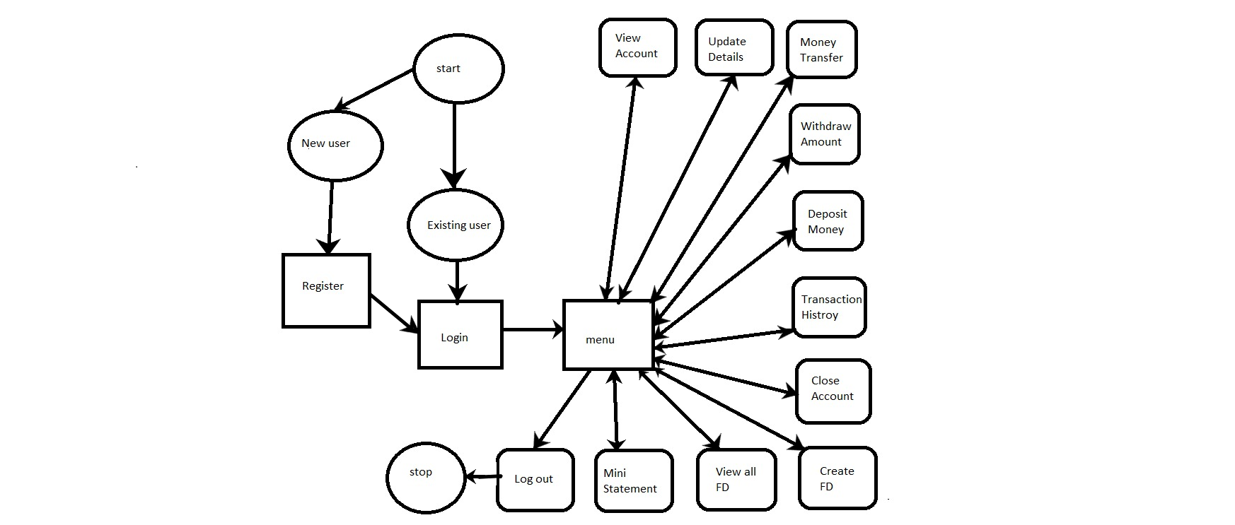

1. **RESULTS AND DISCUSSION**

**Login page:**

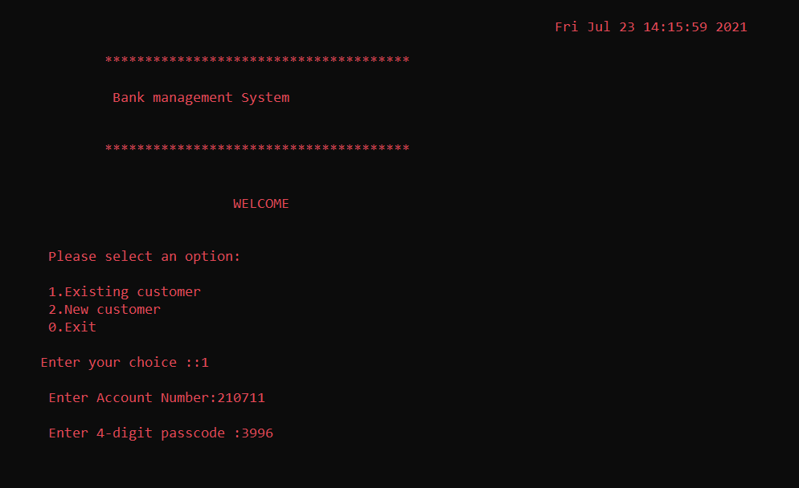

**Registration(for new user):-**

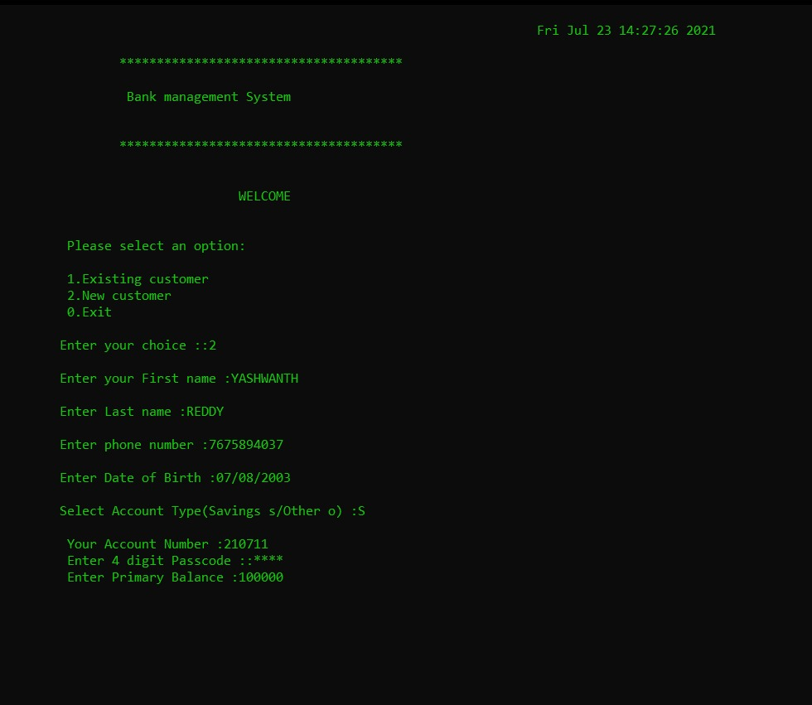

**Menu:**

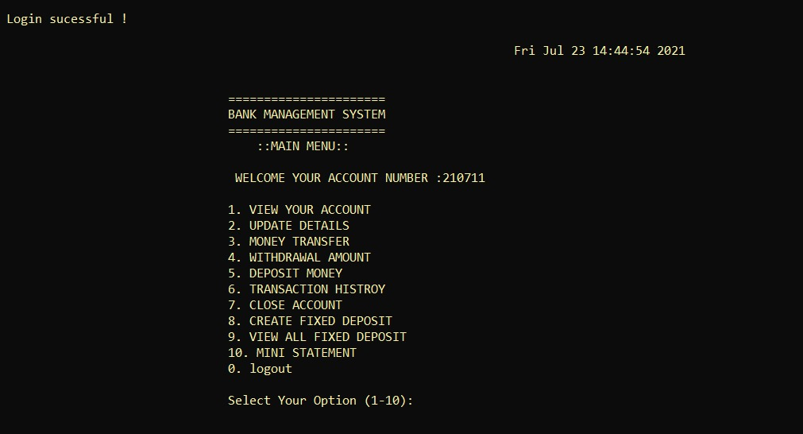

**Depositing in account:-**

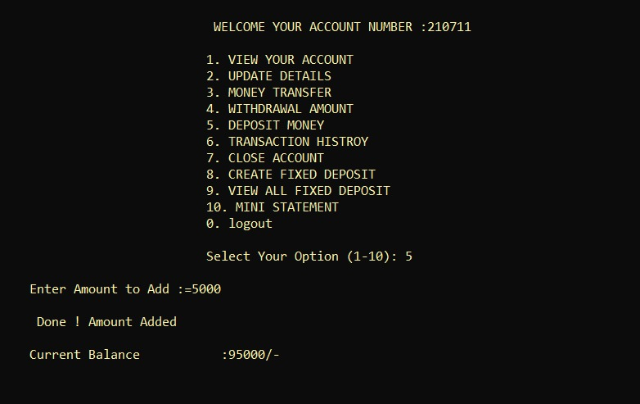

**Viewing the account details:-**

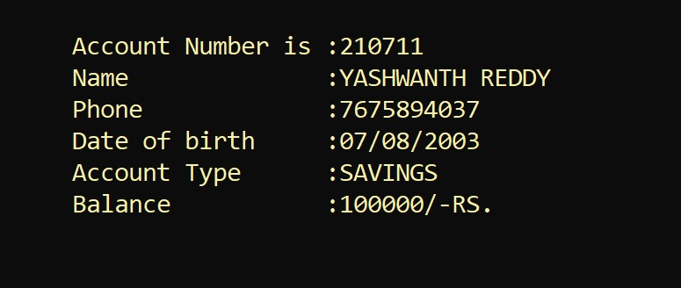

**Money transferring (from one account to another):-**

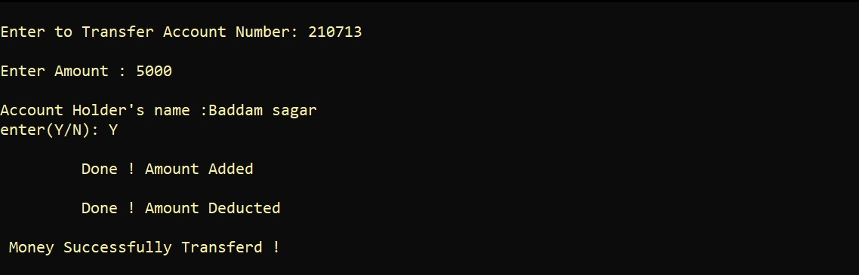

**Withdrawing money from the account:-**

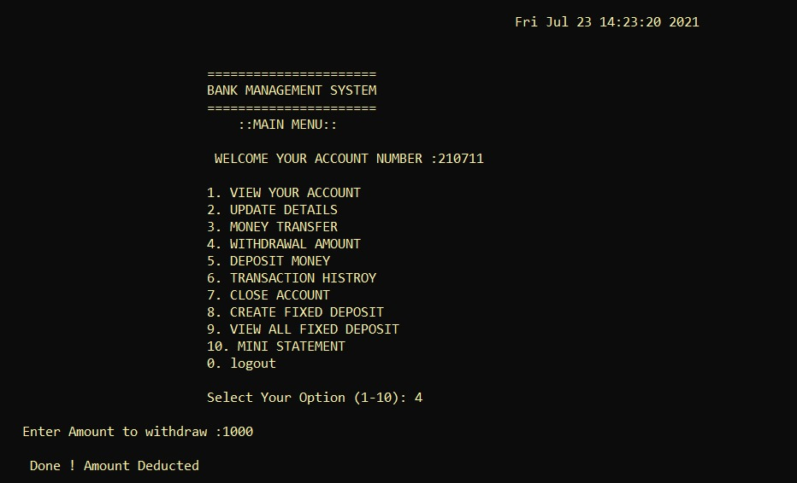

**Making a fixed deposit:-**

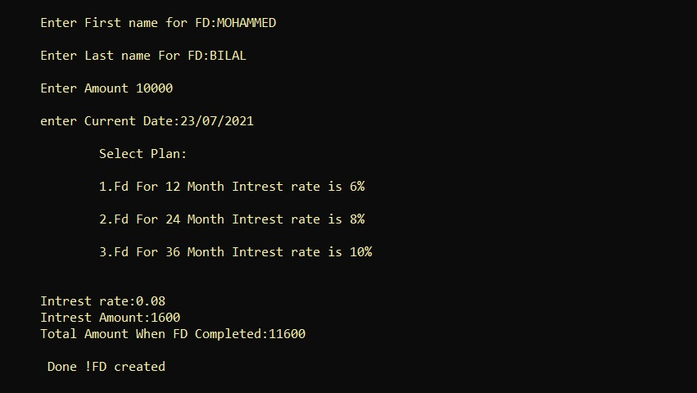

**Viewing the details of fixed deposit:-**

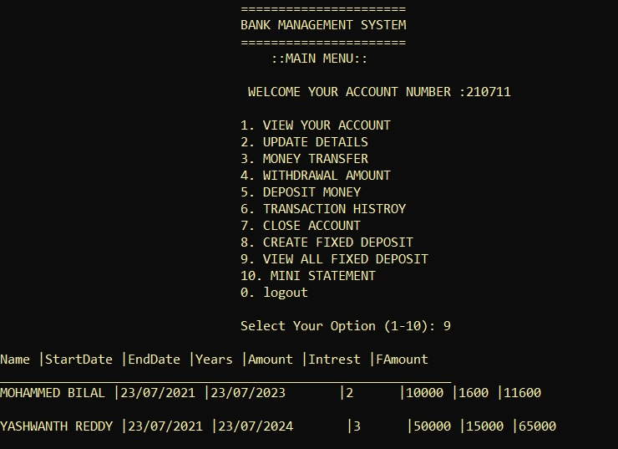

**Transaction history:-**

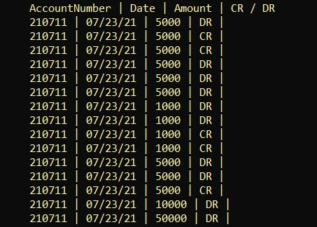

**Mini statement of the bank account:-**

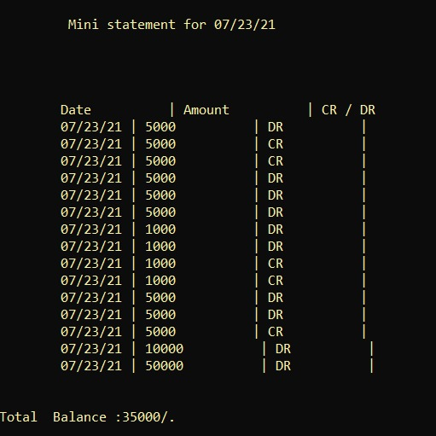

**7 REFERENCES:**

1. https://youtu.be/vNT4P23ihCo
2. https://youtu.be/azDHNMUuKcA
3. https://www.geeksforgeeks.org/how-to-print-colored-text-in-c/
4. https://www.tutorialspoint.com/cplusplus/cpp_date_time.htm
5. https://youtu.be/GjzyCUqDMoA
6. https://www.geeksforgeeks.org/file-handling-c-classes/
7. https://youtu.be/LV5BUQgZcWI
8. https://instapdf.in/let-us-c-by-yashwant-kanetkar-2/